Name

Mathematics Advanced Year 11
Sets and Set Notation

Book 1 |  | Version: 250903  Feedback:  https://MrDingMaths.com
Contents
Syllabus Content 2
Learning Intention 9

Syllabus Content
MAV-11-10 displays and analyses datasets using summary statistics and graphical representations
Sets and set notation
- Define a set as a collection of objects, called the elements of the set, and represent a set using notation such as $\left\{2,3,5,7\right\}$ and $\{0,2,4,6,…\}$
- Use the notation $n\left(A\right)$ or $\left|A\right|$ to represent the number of elements in a finite set $A$
- Define the empty set as the set with no elements, denoted in set notation as $∅$
- Use the notation $\bar{A}$, $A'$ or $A^{c}$ to represent the complement of a set $A$ with respect to some universal set $U$
- Define $A$ to be a subset of $B$ if all the elements of $A$ are elements of $B$
- Define the intersection $A∩B$ of sets $A$ and $B$ to be the set of elements that are in $A$ and in $B$
- Define the union $A∪B$ of sets $A$ and $B$ to be the set of elements that are in $A$ or in $B$
- Define sets $A$ and $B$ to be disjoint if $A∩B=∅$, that is, they have no elements in common
- Use Venn diagrams in practical situations to represent and interpret sets that may intersect in various ways within a universal set
- Establish and use the rule $\left|A∪B\right|=\left|A\right|+\left|B\right|-\left|A∩B\right|$

Set Notation

- Sets
A set is a collection of elements (objects).
We use { } to represent a set. Each element is separated by commas.
Sets have no repeated elements and no order.
The empty set has no elements, denoted in set notation as: $∅$

- Interpret set notation.
“$x$ is the set of numbers 7, 3, 2, 14”:  $$x=\left\{7, 3, 2, 14\right\}$$ | “$y$ is the set of numbers 6, 2, 2, and 7”:  $y=\left\{6, 2, 7\right\}$
Use set notation to list the elements of each of these sets.
- $A=${even numbers between 10 and 20 inclusive} | - $B=$ {days of the week}
- $C=${letters in the word “integer”} | - $D=$ {negative real square numbers}

- Element of Symbol
$a ∈ X$ means $a$ is included in set $X$.
“$a$ is an element of $X=\left\{a, b, c\right\}$”
$$a∈X$$

- Interpret element of symbol.
✖  $$4∉\left\{1,2,3\right\}$$ | ✔  $$2∈\left\{1,2,3\right\}$$ |  | ✔  $$dog∈\left\{cat, dog\right\}$$ |  | ✔  $$32.5∈R$$ |  | ✖  $$\sqrt{-3}∉R$$
Write the correct symbol, $∈$ or $∉$.

4 …… $\left\{1, 2, 3\right\}$ |  | 1 …… {12, 13, 15} |  | $\sqrt{5}$ …… $R$ |  | red …… {blue, black}

- Number of Elements
$n\left(A\right)$ or $\left|A\right|$ represents the number of elements inside set $A$.

- Interpret number of elements notation.
$$A=\left\{2,5,6,11\right\} \\ n\left(A\right)=4$$ | $$X=\left\{dog,cat,wednesday\right\} \\ n\left(X\right)=3$$ |  | $$S=\left\{even prime numbers\right\} \\ n\left(A\right)=1$$
Determine the number of elements in these sets.
- $A=\left\{9,8,23,77,-2\right\}$  $n\left(A\right)=$ |  | - $B=${months of the year}  $\left|B\right|=$
- $S=${letters in the word “integer”}  $\left|S\right|=$ |  | - $C=$ {prime numbers between 1 and 10}  $n\left(C\right)=$

- Universal Sets and The Complement
$U$ or $ξ$is the universal set that contains all elements we’re considering.
$\bar{A}$, $A'$ or $A^{c}$ represents the complement of set $A$.
The complement contains all elements that are in the universal set $U$ but are NOT in set $A$.
$A$ and $A^{'}$ together make up the universal set.

- Interpret universal sets and complement sets.
$$U=\left\{Integers between 0 and 10, inclusive\right\}$$  $=\left\{0, 1, 2, 3, 4, 5, 6, 7, 8, 9, 10\right\}$  $$A=\left\{Even integers\right\}$$  $=\left\{0, 2, 4, 6, 8, 10\right\}$  $$A^{'}=\left\{Not even integers\right\}$$  $=\left\{1, 3, 5, 7, 9\right\}$ | $$ξ=\left\{Integers between 0 and 10, inclusive\right\}$$  $=\left\{0, 1, 2, 3, 4, 5, 6, 7, 8, 9, 10\right\}$  $$A=\left\{Multiples of 3\right\}$$  $=\left\{0, 3, 6, 9\right\}$  $$A^{c}=\left\{Not multiples of 3\right\}$$  $=\left\{1, 2, 4, 5, 7, 8, 10\right\}$
List the elements for these sets, given the universal set.
- $U=\left\{days of the week\right\}$  $A=\left\{weekdays\right\}$  $A^{'}=$ | - $U=\left\{square numbers up to 100, inclusive\right\}$  $B=\left\{multiples of 5\right\}$  $B^{'}=$
- $ξ=\left\{Factors of 12\right\}$  $A=\left\{even factors\right\}$  $A^{c}=$ | - $ξ=\left\{Multiples of 4 up to 28, inclusive\right\}$  $A=\left\{odd multiples\right\}$  $\overline{A}=$

- Subsets
$A$ is a subset of $B$ if every element in $A$ is also in $B$.
“A is a subset of B”
$$A⊆B$$
- Every set is a subset of itself: A ⊆ A
- Empty set is subset of every set: ∅ ⊆ A
- A ⊂ B means A ⊆ B AND A ≠ B

- Identify subsets.
✖  A = {1, 3, 7}  B = {1, 3, 5}  $$A⊄B$$ | ✔  A = {1, 3}  B = {1, 3, 5}  $$A⊆B$$ |  | ✔  A = {R, B, G}  B = {R}  $$B⊆A$$ | ✔  X = {4, 2, 8, 6}  Y = {2, 4, 6, 8}  $$X⊆Y$$  $$Y⊆X$$ |  | ✖  X = {2, 4, 0}  Y = {2, 4, 6, 8}  $$X⊄Y$$
Write the correct symbol $⊆$ or $⊄$ to relate the two sets.
- A = {2, 4}  B = {1, 2, 3, 4, 5} |  | - A = {a, c}  B = {a, b, d} |  |  | - A = {real numbers $R$}  B = {integers $Z$}
- X = {3, 4, 5}  Y = {5, 3} |  | - A = {x, y, z}  B = {z, y, x} |  |  | - H = {2, 3}  K = {6}

- Intersection of Sets
The intersection of sets $A$ and $B$ are the set of elements that are both in $A$ and in $B$.
“Intersection of A and B”
$$A∩B$$

- Interpret intersections of sets.
A = {1, 3, 5, 7}  B = {3, 5, 9, 11}  A ∩ B = {3, 5} | C = {red, blue, green}  D = {blue, green, yellow}  C ∩ D = {blue, green} | E = {2, 4, 6}  F = {1, 3, 5}  E ∩ F = $∅$
Identify the intersection of these sets.
A = {1, 2, 3, 5, 8}  B = {2, 3, 4, 7} | C = {d, b, c, a}  D = {c, d, e, f} | C = {red, green, blue}  D = {green, orange, purple}

- Mutually Exclusive or Disjoint Sets
Two sets $A$ and $B$ are mutually exclusive (or disjoint) if they have no elements in common.
The intersection of $A$ and $B$ is an empty set.
$$A∩B=∅$$

- Identify disjoint/mutually exclusive sets.
Not mutually exclusive  A = {1, 3, 7}  B = {1, 5} | Mutually  exclusive  A = {1, 3, 7}  B = {2, 5} |  | Mutually  exclusive  A = {R, B, G}  B = {Y} | Mutually  exclusive  X = {positive}  Y = {negative} |  | Not mutually exclusive  X = {5, 6, 7}  Y = {1, 7, 12}
Identify which of these pairs of sets are mutually exclusive.
- A = {x, y}  B = {a, b} |  | - A = {a, c}  B = {a, b, d} |  |  | - A = {real numbers $R$}  B = {integers $Z$}
- X = {odd numbers}  Y = {even numbers} |  | - A = {prime numbers}  B = {multiples of 3} |  |  | - H = {humans}  K = {mammals}

- Union of Sets
The union of sets $A$ and $B$ are the set of elements that are in either $A$ or in $B$.
“Union of A and B”
$$A∪B$$

- Interpret unions of sets.
A = {1, 3}  B = {2, 3, 6}  A ∪ B = {1, 2, 3, 6} | C = {red, blue}  D = {blue, green}  C ∪ D = {red, blue, green} | E = {a, b}  F = {c, d}  E ∪ F = {a, b, c, d}
Identify the union of these sets.
A = {1, 2}  B = {3, 4} | C = {1, 2, 3}  D = {3, 4, 5} | C = {1, 2, 3}  D = {1, 2, 3}
A = {1, 2}  B = {1, 2, 3, 4} | C = {red, blue}  D = {green, blue, yellow} | C = {1, 2, 3, 4}  D = {4, 1, 7, 5}

- Example interpret set notation.
$$Universal set U = \{1, 2, 3, 4, 5, 6, 7, 8, 9, 10\}$$
$$Set A = \{2, 4, 6, 8\}$$
$$Set B = \{1, 2, 3, 4\}$$
$$Set C = \{5, 7, 9\}$$
For each question, write the meaning in English and give the answer.
- A ∪ B  Elements in either A or B = {1, 2, 3, 4, 6, 8} | - A ∩ B  Elements in both A and B = {2, 4}
- B ∪ C  Elements in either B or C = {1, 2, 3, 4, 5, 7, 9} | - A ∩ C  Elements in both A and C = ∅
- n(A)  Number of elements in A = 4 | - |C|  Number of elements in C = 3
- n(A ∪ B)  Number of elements in A or B = 6 | - A'  Complement of A = {1, 3, 5, 7, 9, 10}
- $\overline{B}$  Complement of B = {5, 6, 7, 8, 9, 10} | - Which sets are mutually exclusive?  A and C
True or false?
- A ⊆ B?  A subset of B? False.  (6 and 8 are in A but not in B) | - B ⊆ A?  B subset of A? False.  (1 and 3 are in B but not in A)
- {2, 4} ⊆ A?  {2, 4} subset of A? True.  (both 2 and 4 are elements of A) | - B ⊆ U?  B subset of the universal set? True.
Find the following by writing out each set combination separately.
- (A ∪ B) ∩ C  {1, 2, 3, 4, 6, 8} ∩ {5, 7, 9} = ∅ | - A ∩ B'  {2, 4, 6, 8} ∩ {5, 6, 7, 8, 9, 10} = {6, 8}
- (A ∪ C)'  {2, 4, 5, 6, 7, 8, 9}' = {1, 3, 10} | - n(A ∪ C)'  3

Foundation
- Geri asks 10 students in her class to name their favourite colour. Geri writes the results as set A. A = {green, purple, pink, red, blue, red, red, green, orange, red}.
Explain the mistake that Geri has made.

Sets cannot contain duplicate elements - "red" appears 4 times
- Write down the following sets by listing their members.
  - Odd positive integers less than 10.
{1, 3, 5, 7, 9}
  - The first six positive multiples of 6.
{6, 12, 18, 24, 30, 36}
  - The numbers on a die.
{1, 2, 3, 4, 5, 6}
  - The factors of 20.
{1, 2, 4, 5, 10, 20}

- List the elements of each of these sets. Use correct set notation.
  - X = {multiples of 7 between 20 and 40}
X = {21, 28, 35}
  - Y = {seasons in a year}
Y = {spring, summer, autumn, winter}
  - Z = {letters in the word "science"}
Z = {s, c, i, e, n}

- ξ = {2, 4, 6, 8, 10, 12, 14},
A = {2, 4, 8, 12}.
Write down the elements of A'.
A' = {6, 10, 14}
- A = {10, 11, 12, 13, 14, 15},
B = {12, 13, 14}.
List the elements of A ∩ B.
A ∩ B = {12, 13, 14}
- A = {red, white, blue},
B = {green, red, yellow, black}.
List the elements of A ∩ B.
A ∩ B = {red}
- If A = {1, 3, 5}, B = {3, 4} and E = {1, 2, 3, 4, 5}, find:
  - |A|
  - |B|
|A| = 3
|B| = 2

- ξ = {numbers from 1 to 50},
A = {odd numbers},
B = {even numbers},
C = {multiples of 10},
D = {square numbers}.
  - List all the elements of set D.
D = {1, 4, 9, 16, 25, 36, 49}
  - List all the elements that are in both set B and set D.
B ∩ D = {4, 16, 36}
  - Explain why there are no elements that are listed in both set A and set C.
All multiples of 10 are even, but A contains only odd numbers
  - List the elements that are in set C or D or both.
C ∪ D = {1, 4, 9, 10, 16, 20, 25, 30, 36, 40, 49}

- A = {factors of 12}, B = {factors of 30}.
  - List the elements of set A.
A = {1, 2, 3, 4, 6, 12}
  - List the elements of set B.
B = {1, 2, 3, 5, 6, 10, 15, 30}
  - Which numbers are in both set A and set B?
A ∩ B = {1, 2, 3, 6}

- Mateusz and Hannah are writing down as many three-letter words beginning with 't' as possible in 30 seconds.
M = {tab, tan, tam, the, tea, ten},
H = {tap, tax, tan, the, ten}.
  - List the elements of M ∪ H.
M ∪ H = {tab, tan, tam, the, tea, ten, tap, tax}
  - Describe what M ∪ H tells you.

b) All three-letter words beginning with 't' that either student wrote
- ξ = {1, 2, 3, 4, 5, 6, 7, 8, 9, 10},
A = {2, 4, 6, 8, 10},
B = {5, 10},
C = {2, 3, 5, 7}. Write down the elements of each of these sets.
  - A ∪ B
A ∪ B = {2, 4, 5, 6, 8, 10}
  - A ∪ C
A ∪ C = {2, 3, 4, 5, 6, 7, 8, 10}
  - B ∪ C
B ∪ C = {2, 3, 5, 7, 10}

Development
- X = {multiples of 5 between 12 and 33},
Y = {even numbers}.
List the elements of X ∩ Y.
X = {15, 20, 25, 30}, Y = {even numbers}
X ∩ Y = {20, 30}
- ξ = {multiples of 5 between 1 and 49},
A = {multiples of 3},
B = {multiples of 2}.
  - Write down the elements of A ∪ B.
  - Write down the elements of A ∩ B.
ξ = {5, 10, 15, 20, 25, 30, 35, 40, 45}
A ∪ B = {10, 15, 20, 30, 40, 45}
A ∩ B = {30}
- ξ = {e, g, h, m, n, p, s, t},
A = {h, p, s, t},
B = {e, g, h, m, p, t}.
Write down the elements of each of these sets.
  - A'
A' = {e, g, m, n}
  - B'
B' = {n, s}
  - (A ∩ B)'
A ∩ B = {h, p, t}, so (A ∩ B)' = {e, g, m, n, s}
  - (A ∪ B)'
A ∪ B = {e, g, h, m, p, s, t}, so (A ∪ B)' = {n}
- ξ = {1, 2, 3, 4, 5, 6, 7, 8, 9, 10},
A = {2, 4, 6, 8, 10},
B = {5, 10},
C = {2, 3, 5, 7}.
Write down the elements of each of these sets.
  - B ∪ C
B ∪ C = {2, 3, 5, 7, 10}
  - (A ∪ B) ∪ C
(A ∪ B) ∪ C = {2, 3, 4, 5, 6, 7, 8, 10}
  - Is (A ∪ B) ∪ C the same as (A ∪ C) ∪ B?
Yes

- If A = {1, 3, 5}, B = {3, 4} and universal set U = {1, 2, 3, 4, 5}, find:
  - A ∪ B
A ∪ B = {1, 3, 4, 5}
  - |A ∪ B|
|A ∪ B| = 4
  - A ∩ B
A ∩ B = {3}
  - |A ∩ B|
|A ∩ B| = 1
  - $\overline{A}$
A̅ = {2, 4} (complement in U)
  - $\overline{B}$
B̅ = {1, 2, 5} (complement in U)
- If A = {1, 4, 7, 8} and B = {1, 2, 4, 5, 7}, state whether the following statements are true or false.
  - A = B
False
  - |A| = 4
True
  - |B| = 6
False
  - A ⊂ B
False, 8 is in A but not B
  - A ∪ B = {1, 2, 4, 5, 7, 8}
True
  - A ∩ B = {1, 4, 7}
True
- A = {red, white, blue}, B = {green, red, yellow, black}.
Explain why A ∪ B is not {red, white, blue, green, red, yellow, black}.

sets cannot contain duplicates - "red" would only appear once
- State in each case whether or not A ⊂ B (that is, whether A is a subset of B).
  - A = {2, 3, 5}, B = {1, 2, 3, 4, 5, 6, 7, 8, 9}
True
  - A = {3, 6, 9, 12}, B = {3, 5, 9, 11}
False (6, 12 not in B)
  - A = {d, a, n, c, e}, B = {e, d, u, c, a, t, i, o, n}
True
  - A = {a, m, y}, B = {s, a, r, a, h}
False (m, y not in B)
  - A = ∅, B = {51, 52, 53, 54}
True (empty set is subset of any set)

Mastery
- Decide which elements would need to be removed from event A if the two events A and B described below are to become mutually exclusive.
  - A = {1, 2, 3, 4}, B = {4, 5, 6, 7}
Remove 4 from A
  - A = {10, 12, 14, 16, 18}, B = {9, 10, 11, 12}
Remove 10, 12 from A
  - A = {a, b, c, d, e}, B = {a, c, e, g}
Remove a, c, e from A
  - A = {1, 3, 5, 8, 10, 15, 20, 22, 23}, B = {7, 9, 14, 16, 19, 21, 26}
No elements need removing (already mutually exclusive)

- If A = {students who study Japanese} and B = {students who study History}, carefully describe each of the following sets.
  - A ∩ B
Students who study both Japanese and History
  - A ∪ B
Students who study Japanese or History (or both)

- Find A ∪ B and A ∩ B for each pair of sets.
  - A = {1, 3, 5}, B = {3, 5, 7}
A ∪ B = {1, 3, 5, 7}, A ∩ B = {3, 5}
  - A = {1, 3, 4, 8, 9}, B = {2, 4, 5, 6, 9, 10}
A ∪ B = {1, 2, 3, 4, 5, 6, 8, 9, 10}, A ∩ B = {4, 9}
  - A = {h, o, b, a, r, t}, B = {b, i, c, h, e, n, o}
A ∪ B = {h, o, b, a, r, t, i, c, e, n}, A ∩ B = {h, o, b}
  - A = {j, a, c, k}, B = {e, m, m, a}
A ∪ B = {j, a, c, k, e, m}, A ∩ B = {a}
  - A = {prime numbers less than 10}, B = {odd numbers less than 10}
A = {2, 3, 5, 7}, B = {1, 3, 5, 7, 9}
A ∪ B = {1, 2, 3, 5, 7, 9}, A ∩ B = {3, 5, 7}

Visualising Sets using Venn Diagrams

- Interpret set notation using Venn diagrams.
Shade the region in the Venn diagram that represents the given set.
- $A$  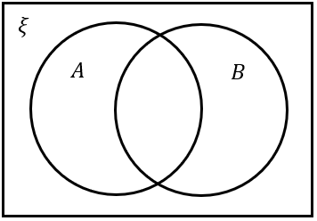 | - $B$ | - $A∩B$
- $A∪B$ | - $\overline{A}$ | - $\overline{B}$
- $\overline{A}∩\overline{B}$ | - $\overline{A}∩B$ | - $A∩\overline{B}$
- $\overline{\left(A∪B\right)}$ | - $ξ$ | - $\left(A∪B\right)-\left(A∩B\right)$

- Venn Diagrams and Sets
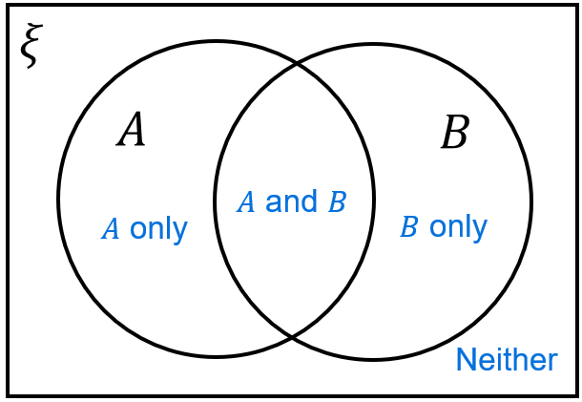

- Addition Rule for Sets
Imagine you’re counting students who study maths or science.
If you add the students who study maths and students who study science,
you will double-count students who study both.
So, you must subtract the people who study both.
$\left|A∪B\right| = \left|A\right|+\left|B\right|-\left|A∩B\right|$
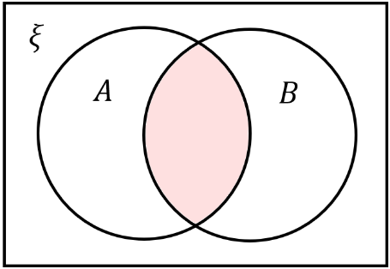
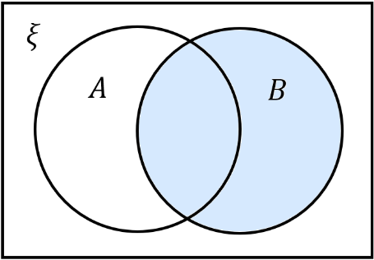
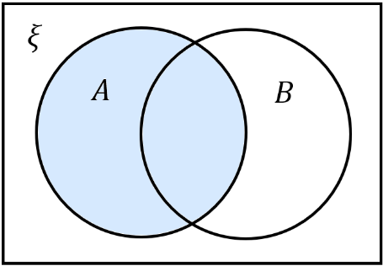
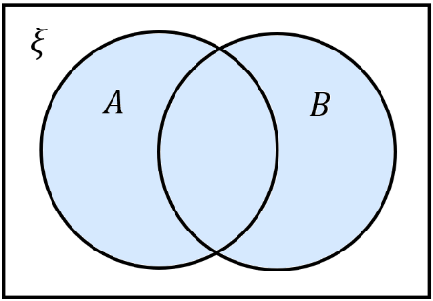

$=$ $+$ $-$

- Example Apply addition rule for sets.
In a sports club, 22 play basketball, 18 play volleyball, and 8 play both sports. How many members play basketball or volleyball?  $$\left|V∪B\right|=\left|V\right|+\left|B\right|-\left|V∩B\right| \\ =22+18-8 \\ =32$$ | A survey of 80 teenagers found that 35 like pop music, 28 like rock music, and 12 like both genres. How many teenagers like pop or rock music?  $$\left|P∪R\right|=\left|P\right|+\left|R\right|-\left|P∩R\right| \\ =28+12-12 \\ =51$$

- Practice
In a school of 120 students, 45 study Spanish, 52 study French, and 15 study both languages. How many students study Spanish or French?  82 | $$A=\left\{whole numbers from 1 to 10 inclusive\right\}$$  $$B=\left\{even numbers from 1 to 15\right\}$$  Find $\left|A∪B\right|$ without listing the set.  12

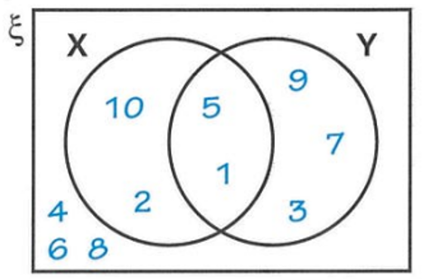
Foundation

- List the elements of set X.  $$X = \{10, 5, 2, 1\}$$ | - List the elements of set Y.  $$Y = \{9, 5, 1, 7, 3\}$$
- List the elements of both set X and set Y.  $$X ∩ Y = \{5, 1\}$$ | - List the elements of set X or set Y.  $$X∪Y=\left\{10, 5, 2, 1,9, 7, 3\right\}$$
- List the elements that are not in set X.  $$\overline{X}=\left\{4, 6, 8, 9, 7, 3\right\}$$ | - List the elements that are not in set Y.  $$\overline{Y}=\left\{10, 2, 4, 6, 8\right\}$$

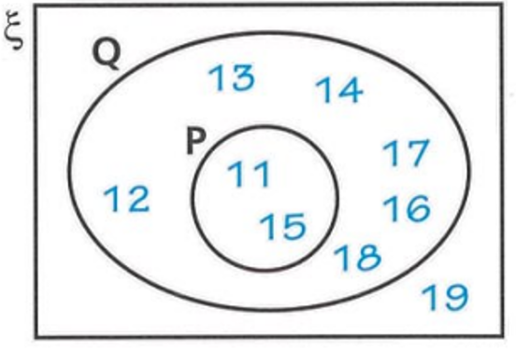

- List the elements of set P.  $$P=\left\{11, 5\right\}$$ | - Sven says that 11 is not an element of set Q. Is Sven correct?  Sven is incorrect. 11 is an element of Q
- Write down the elements of set Q.  $$Q=\left\{12, 13, 14, 17, 16, 18, 11, 15\right\}$$ | - How many elements are not in set Q?  $$1$$
- How many elements are not in set P?  $$7$$ | - Explain why the set “both P and Q” are the same as those of set P.  P ⊆ Q (P is subset of Q)

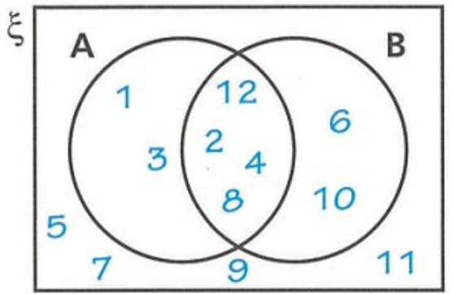

- List the elements of A ∩ B.  $$A∩B=\left\{12, 2, 4, 8\right\}$$ | - List the elements of A ∪ B.  $$A∪B=\left\{1, 3, 2, 12, 4, 8, 6, 10\right\}$$
- List the elements of A'.  $$A^{'}=\left\{5, 7, 9, 6, 10 ,11\right\}$$ | - List the elements of B'.  $$B^{'}=\left\{1, 3, 5, 7, 9, 11\right\}$$

- Shade the region:
A ∩ B A ∪ B
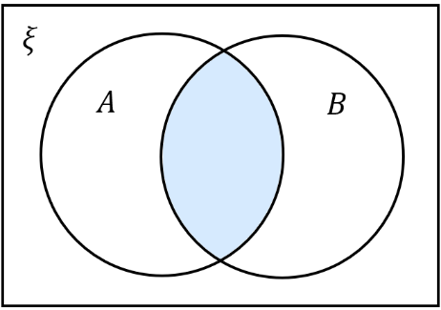
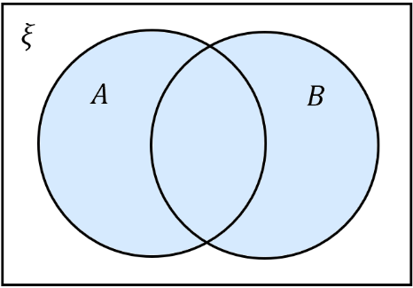
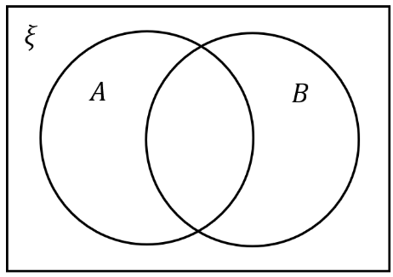
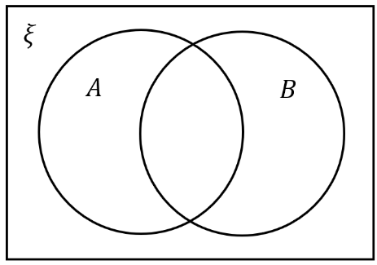

- On each diagram, shade the region A'.
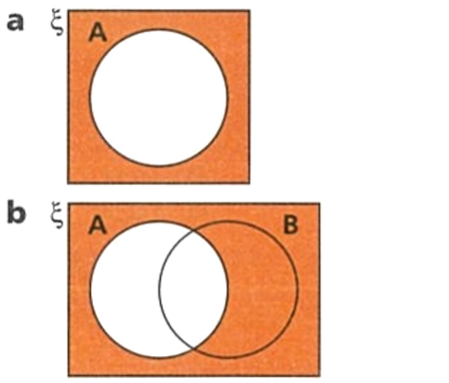
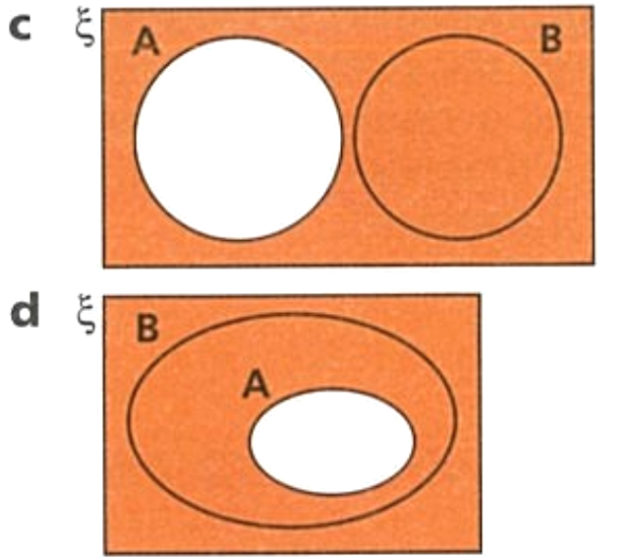
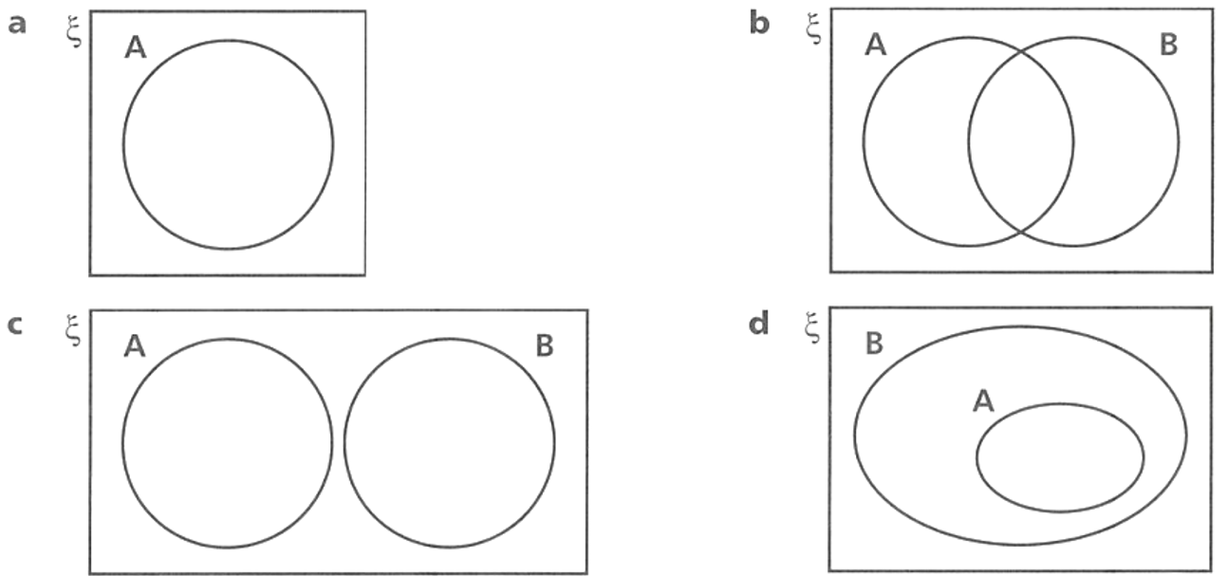

- The two Venn diagrams show A and $B'$.
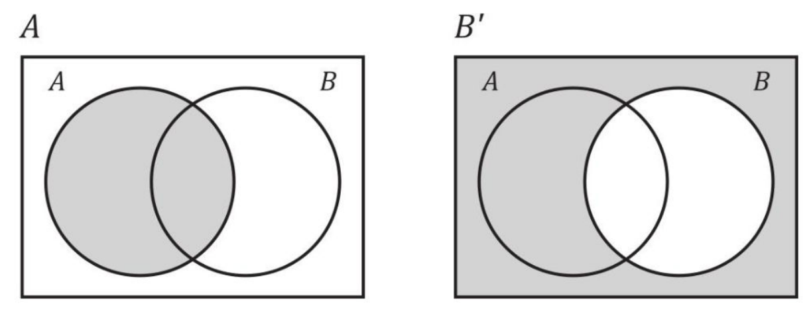

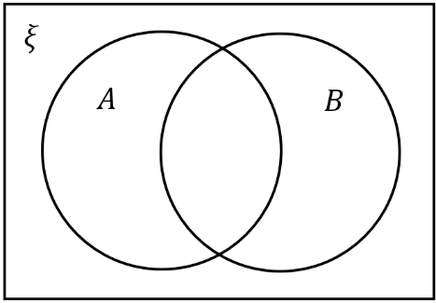  - Shade $A∪B'$ by shading everything that is either in the first picture or in the second picture. | 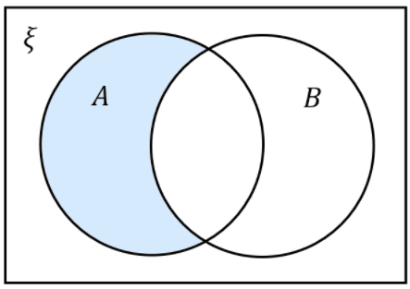  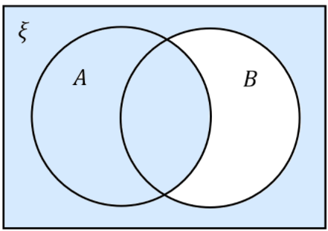  - Shade $A∩B'$ by shading anything that is in both the first and second picture

- The two Venn diagrams show $A’$ and B.
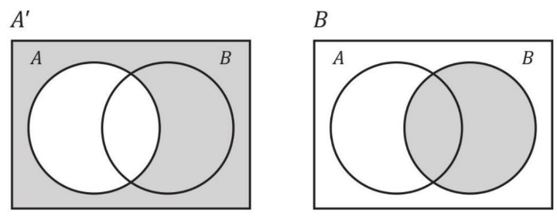

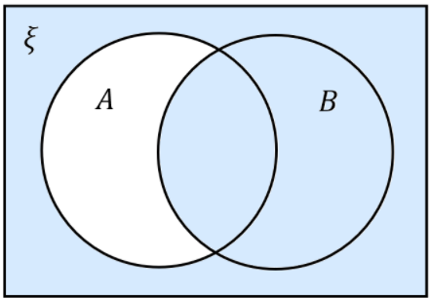  - Shade $A'∪B$ | 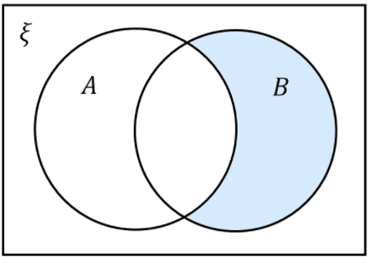  - Shade $A'∩B$

Development
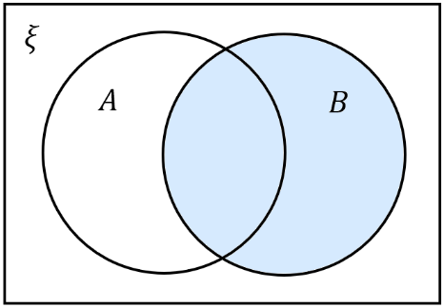
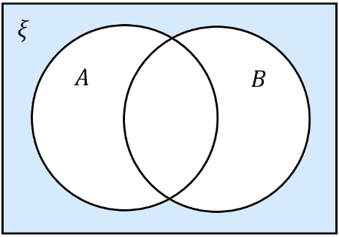
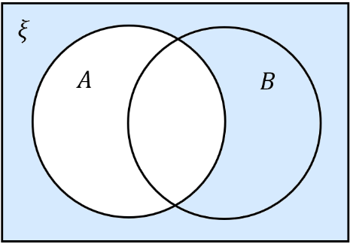
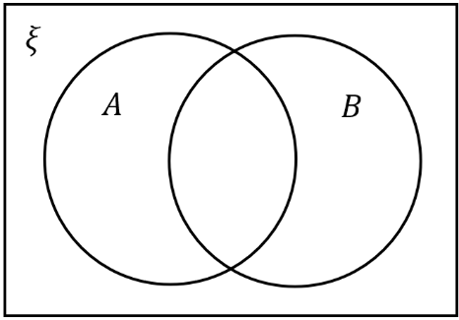
- Shade the Venn diagrams with the set.
- $A$  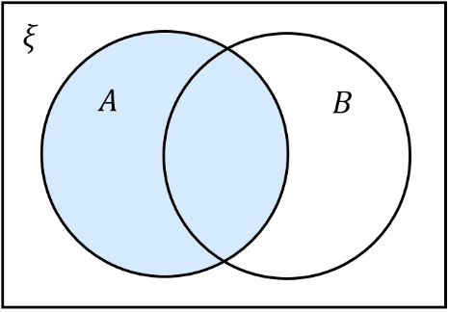 | - $B$ | - $A∩B$ | - $A∪B$
- $A∩\overline{B}$  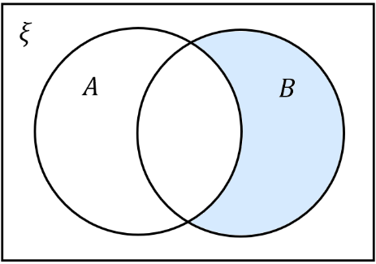  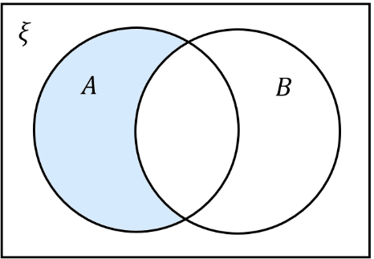 | - $\overline{A}∩B$ | - $\overline{A}$ | - $\overline{A}∩\overline{B}$

- Here are two sets, A and B.
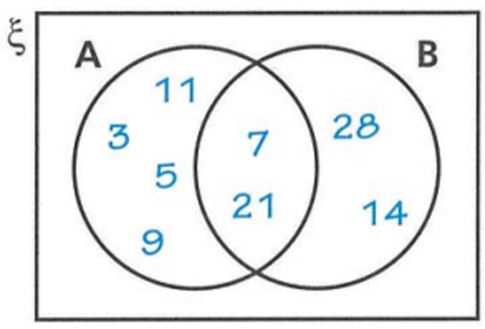
  - Write the elements of $A∪B$
$$A∪B=\left\{3, 11, 5, 9 , 7, 21, 28, 14\right\}$$
  - Write the elements of $A∩B$
$$A∩B=\left\{7, 21\right\}$$
  - Write down the elements of $\overline{A}∩B$.
$$\overline{A}∩B=\left\{28, 14\right\}$$
  - Write down the elements of $A∩\overline{B}$.
$$A∩\overline{B}=\left\{11, 3, 5, 9\right\}$$
- ξ = {1, 2, 3, 4, 5, 6, 7, 8} A = {1, 2, 3, 4, 5} B = {2, 3, 4}
Which of the Venn diagrams would you use to represent these sets?
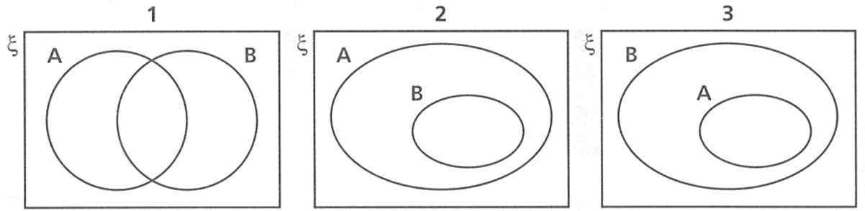

Venn diagram 2, B is a subset of A
- Here are two sets represented on a Venn diagram.
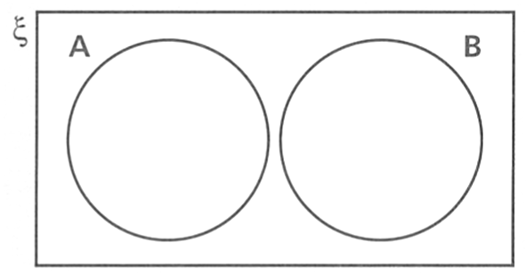
  - Explain why A ∩ B does not contain any elements.
The two sets are disjoint (mutually exclusive)
There are no elements common to A and B
  - Give an example of two possible sets A and B.
Even numbers, odd numbers

- Here are two sets represented on a Venn diagram.
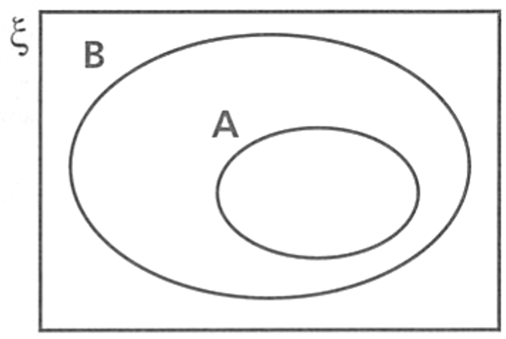
  - Explain why A ∩ B is equal to the elements of set A.
A is a subset of B
So every element of A is in B
  - Give an example of two possible sets A and B.
B: even numbers, A: multiples of 4
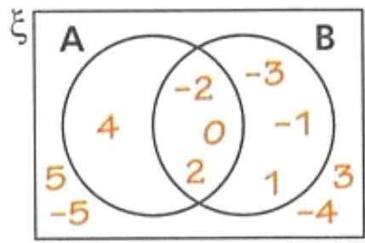
- ξ = {numbers from -5 to 5 inclusive}
A = {-2, 0, 2, 4} B = {-3, -2, -1, 0, 1, 2}
Draw a Venn diagram to represent this information.

- ξ = {integers between 1 and 20 inclusive}
List the elements of these sets.
  - A = {odd numbers}
  - B = {multiples of 2}
  - Draw a Venn diagram to represent the information.
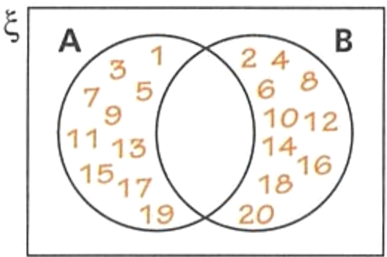
  - Why are there no elements in both set A and set B?
$$A = \left\{1, 3, 5, 7, 9, 11, 13, 15, 17, 19\right\}$$
B = {2, 4, 6, 8, 10, 12, 14, 16, 18, 20}
No number is both odd and even

- In a class of 30 students, 18 play soccer, 12 play basketball, and 7 play both sports.
How many students play soccer or basketball?

18 + 12 – 7 = 23

- In a group of 150 employees, 65 have a car, 85 have a smartphone, and 40 have both.
How many employees have a car or a smartphone?

65 + 85 – 40 = 110

- A gym has 150 members. 90 use the weights, 110 use cardio equipment.
If all members use at least one type of equipment, how many use both?

150 = 90 + 110 – $x$
$$x=50$$
- 40 children take part in a school show. All the children either sing, dance or do both.
35 children dance. 28 children sing.
How many children sing and dance?
Using addition rule, $40=35+28-x$
$$x=23$$

Mastery
- Select the Venn diagram that best shows the relationship between each pair of sets A and B:
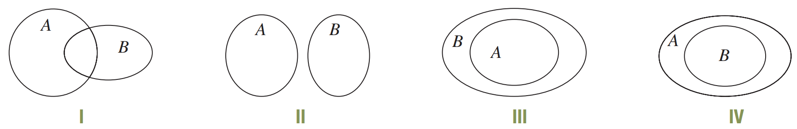

  - A = {Tasmania}, B = {states of Australia}
III
  - A = {7, 1, 4, 8, 3, 5}, B = {2, 9, 0, 7}
I
  - A = {l, e, a, r, n}, B = {s, t, u, d, y}
II
  - A = {politicians in Australia}, B = {politicians in NSW}.
IV

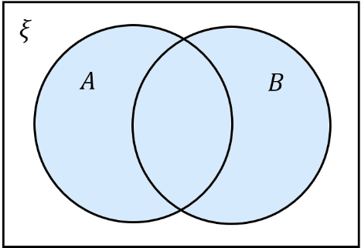  - Shade $A∪B$  Hence shade $\overline{A∪B}$ | - Shade $\overline{A}$  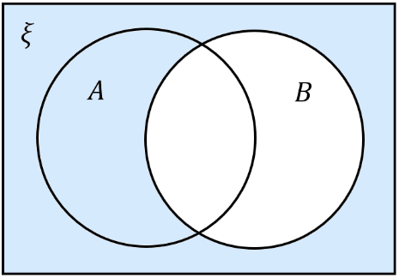  Shade $\overline{B}$  Shade $\overline{A}∩\overline{B}$
- Hence what can you conclude about $\overline{A∪B}$ and $\overline{A}∪\overline{B}$?

They are the same

- Identify the following regions:
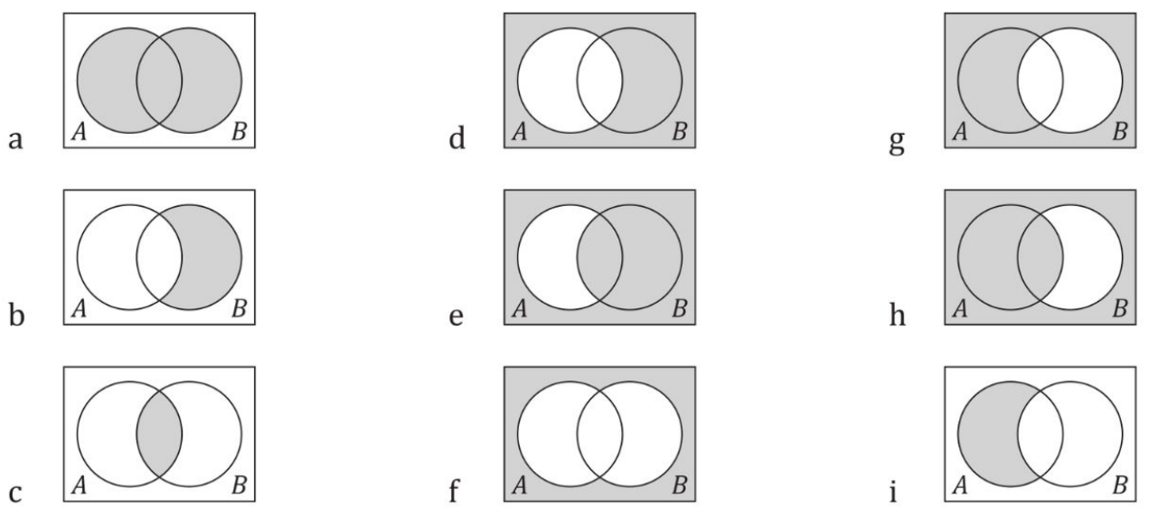  $$A∪B$$ | $$A'$$ | $$B'$$
$$\overline{A}∩B$$ | $$\overline{A}∪B$$ | $$A∪\overline{B}$$
$$A∩B$$ | $$\overline{A∪B} or \overline{A}∪\overline{B}$$ | $$A∩\overline{B}$$

- Here are three sets X, Y and Z. Write down the elements of
  - X ∩ Y
{D, G}
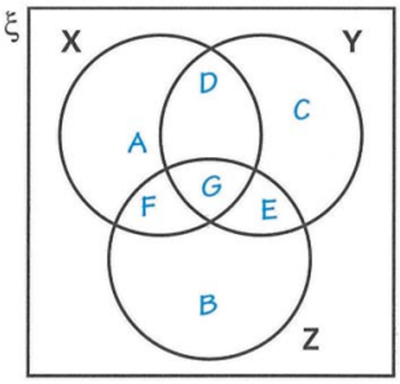
  - Y ∩ Z
{G, E}
  - (X ∩ Y) ∩ Z
G
  - Y'
A, F, B
  - X' ∪ Y'
{C, E, B, A, F}
  - X ∪ Y'
{A, D, G, F, B}
  - (X ∪ Y)'
{B}
  - (X ∪ Y) ∩ Z'
{A, D, C}

- Shade the region $\left(A∩B\right)∪C$  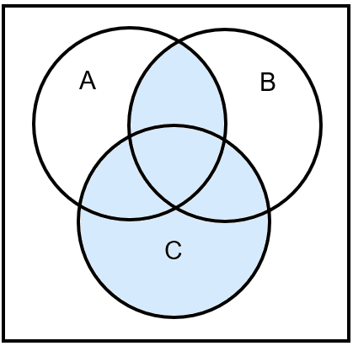  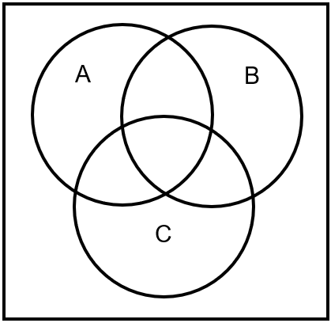 | 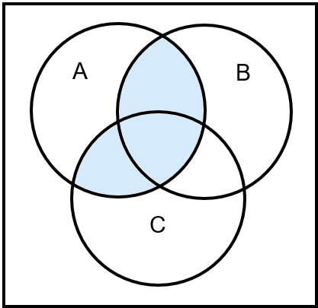  - Shade the region $A∩\left(B∪C\right)$

